**These methods are very frequently used**

for in () { }

it is made for objects mostly not for arrays

for of( ) { }

it is just a simpler version of the regular for loop

So use this one for the arrays

for Each ( )

this once can run a callback function for each items of the array

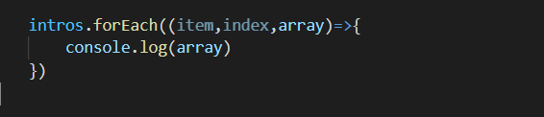

Call function takes three arguments

item , index and also the entire array

use whatever is needed as per the condition

.map ( )

map creates a new array by transforming every element in an array individually

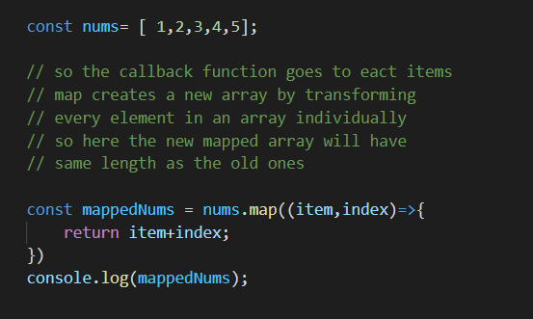

let say we wanna make array from above with only even items

We can’t do this with map

Even if we try

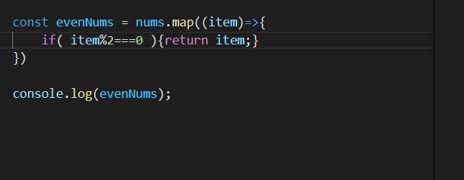

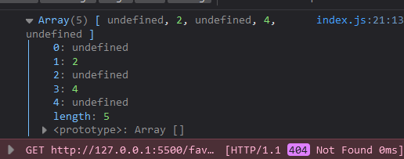

In the odd numbers places there is undefined, this happened since .map ( ) method runs for every items of array, we cannot skip any item if we needed

We can sense that we need to filter out some if the items

there is a

.filter() method for this

filter creates a new array by removing elements that don't belong

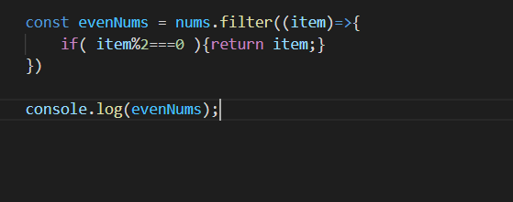

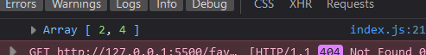

.every() checks if every items of array passes a certain test provided, return type id Boolean

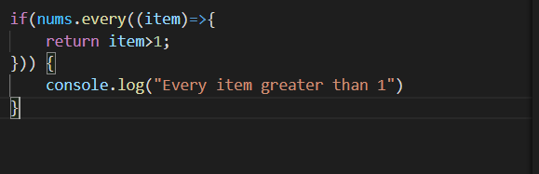

.some( ) checks if some item passes the test, here even if single item passes the test it returns true



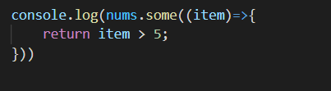 

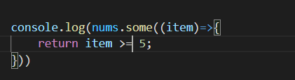 

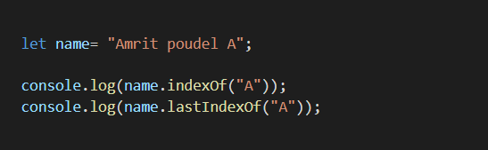 

indexOf () checks for the very first index of the passed item

Same

but

lastIndexOf() checks for the last index of the passed items

Same for arrays

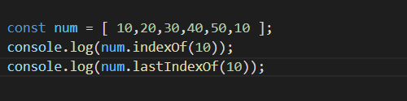 

**.find() this is used to search for an item in the array that passes the provided test, it returns the very first finding**

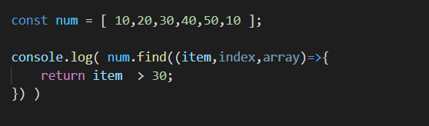

**.findIndex( ) it finds the index of the element that passes the provided test first**

it also takes item,index,array as arguments

Must be wondering why every methods takes these 3 arguments

This is very very very handy and super useful at various complex cases

See

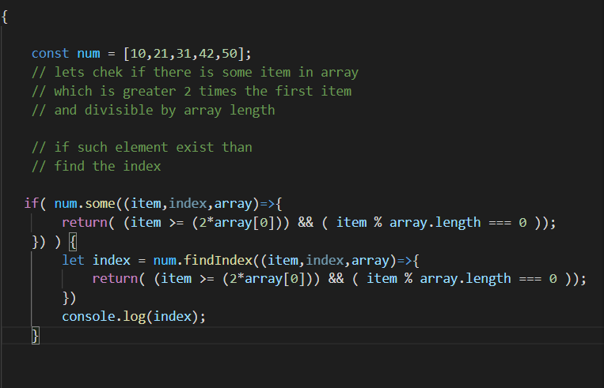

**Array.from() it is used to create an array from the string**

**.includes() used to check if the array contains the provided item or not**

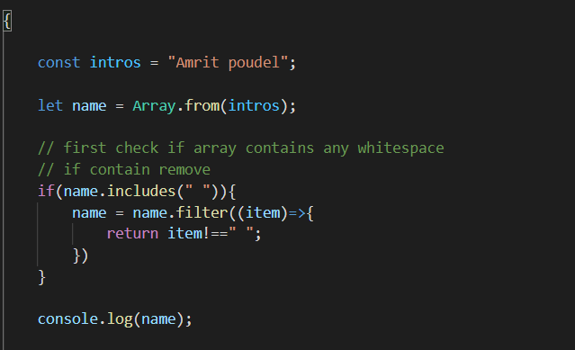

**Array.from() it is used to create an array from the string**

**.includes() used to check if the array contains the provided item or not**

